A Unit of the Shivam Sati Memorial Foundation®

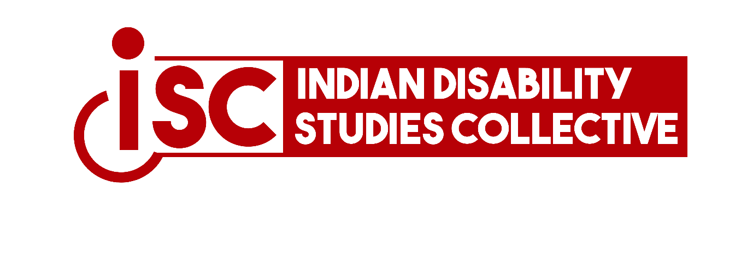
Prof. Someshwar Sati Chairperson, IDSC Email:
someshwarsati@gmail.com M: 9958349702

Prof. Shilpa Das Vice-Chair, IDSC
Email: shilpadas@nid.edu M: 9825654451

Prof. Banibrata Mahanta Vice-Chair, IDSC
Email: bmahantaa@gmail.com M: 9450235443

Dr. Mukul Chaturvedi Secretary, IDSC Email:
drmukulchaturvedi.0709@gmail.com M: 9818144970

Dr. Anurima Chanda Joint-Secretary, IDSC
Email: anurimahere@gmail.com M: 7838609526

Ritwick Bhattacharjee Treasurer, IDSC Email:
ritwick12358@gmail.com M: 9582452545
Call For Papers
4th IDSC International Conference Aligarh Muslim University 21.02.2024 to 23.02.2024

Epistemologies of Disability
The rise of Disability Studies in the second half of the twentieth century brings about a fundamental change in the conceptualisation of the human body. No longer does this body (or, any other body, for that matter) remain constrained inside a tight fabric of a “normal” constitution; a structure dictated, for so long, by the quantitative majority of non-deviant mind-bodies. Obviously, this majority had often been achieved by hiding deviancies both publically and privately in service of the “normal”. Nevertheless, the institutionalisation of Disability Studies brings into common knowledge the complicacies of normalcy and the much real manifestations of all mind-bodily possibilities. Towards the same, Simi Linton writes that the “Disability studies' project is to weave disabled people back into the fabric of society, thread by thread, theory by theory. It aims to expose the ways that disability has been made exceptional and to work to naturalize disabled people-remake us as full citizens whose rights and privileges are intact, whose history and contributions are recorded, and whose often distorted representations in art, literature, film, theatre, and other forms of artistic expression are fully analysed”.
Such renegotiation with existential schemas of the human body needs a radical epistemological shift as well. Since Disability is as much of a discursive establishment, there is a requirement to reconsider and create anew the knowledges (to echo Foucault) that entangles the concept with the paradigms of the everyday. This is not to say that Disability Studies has not done so. There have been significant efforts made to rethink, reanalyse, and remap the discourses of disability towards the re-formation of disability epistemologies. These are the concerns that the fifth Indian Disability Studies Collective (IDSC) International Conference at Aligarh Muslim University from the 21st to the 23rd of February 2024 aims to discuss and deal with. Further, the conference also aims to explore areas which are in need of such epistemological shifts and talk about the methodologies which would enable scholars from across disciplines-be they from the sciences, the humanities, the social science, or law-to dwell on the wide range of disability discourses from varied inter disciplinary perspectives. We invite abstracts, of about 300 words by the 14th December 2023 for the same. The abstracts may find root from the following topics:

A Unit of the Shivam Sati Memorial Foundation®

Prof. Someshwar Sati Chairperson, IDSC Email:
someshwarsati@gmail.com M: 9958349702

Prof. Shilpa Das Vice-Chair, IDSC
Email: shilpadas@nid.edu M: 9825654451

Prof. Banibrata Mahanta Vice-Chair, IDSC
Email: bmahantaa@gmail.com M: 9450235443

Dr. Mukul Chaturvedi Secretary, IDSC Email:
drmukulchaturvedi.0709@gmail.com M: 9818144970

Dr. Anurima Chanda Joint-Secretary, IDSC
Email: anurimahere@gmail.com M: 7838609526

Ritwick Bhattacharjee Treasurer, IDSC Email:
ritwick12358@gmail.com M: 9582452545
- Defining disability and the challenges thereof
- Historical aspects and knowledges of disability
- Disability and representation
- Affectations of disability
- Disability and theology
- Disability and ontology
- Disability as a social phenomenon
- Disability and socio-technological engineering
- Disability and Psychology
- Pedagogical responses and complications to/of disability
- Disability and Inclusive Education
- Disability, Law, and Human Rights
- Disability and Citizenship
- Disability and Globalisation
- Sciences and disability
- Disability and technology
Please email your abstracts to: idscconference2024@gmail.com

NOTE: Only members of the IDSC can be a part of the conference. To avail membership of the IDSC please click on the following Google form link. The Payment slabs for membership are as follows:
For Students/Research Scholars:
Annual: INR 500/-
Three Years’: INR 2500/- Ten Years’: INR 6500/- For Faculty:
Annual: INR 1000/- Three Years’: INR 2500/- Ten Years’: INR 6500/-

All details regarding the payment and payment slabs are mentioned in the form as well.
https://forms.gle/g5qXYfmTT2BUM4416

A Unit of the Shivam Sati Memorial Foundation®

Prof. Someshwar Sati Chairperson, IDSC Email:
someshwarsati@gmail.com M: 9958349702

Prof. Shilpa Das Vice-Chair, IDSC
Email: shilpadas@nid.edu M: 9825654451

Prof. Banibrata Mahanta Vice-Chair, IDSC
Email: bmahantaa@gmail.com M: 9450235443

Dr. Mukul Chaturvedi Secretary, IDSC Email:
drmukulchaturvedi.0709@gmail.com M: 9818144970

Dr. Anurima Chanda Joint-Secretary, IDSC
Email: anurimahere@gmail.com M: 7838609526

Please write to idscmemberships@gmail.com in case you have any query regarding the membership and to idscconference2024@gmail.com for any questions regarding the conference.

NOTE: THE REGISTRATION FEE FOR THE CONFERENCE WILL BE SEPARATE FROM THE IDSC MEMBERSHIP AND WILL BE NOTIFIED TO THE SELECTED PARTICIPANTS

Thanking You

Prof. Someshwar Sati Chairperson, IDSC



Ritwick Bhattacharjee Treasurer, IDSC Email:
ritwick12358@gmail.com M: 9582452545

